**Dodge and Shoot**

**Objective**: we're going to create a very simple moment where we have some obstacles to avoid and some placeholder enemies to shoot at.

First we’re going to leave a buffer around our spaceship so the player never has to squeeze through a tiny keyhole.

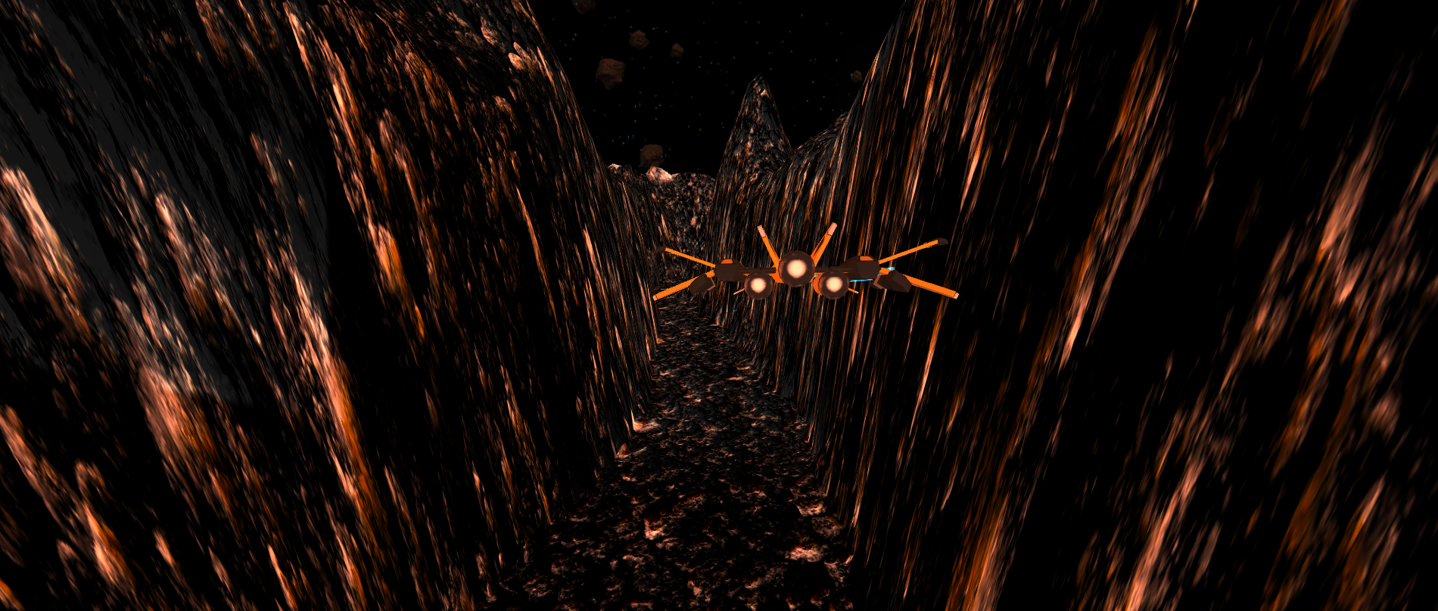

Also we’re going to add obstacles that take up half of the screen so the player has to move to the far left/right in order to survive.



1. We’re going to create these obstacles and maybe put some temporary static cubes for our player to dodge. We can also make it to where if our player shoots these cubes we can log a success message in the console.
2. Click on the **Terrain** and lets get our **Raise/Lower terrain paint brush** tool and create an obstacle to force our player left or right.

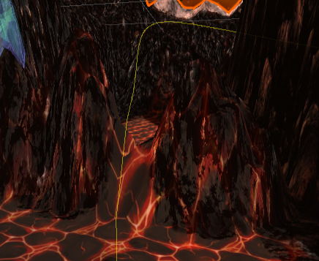

1. Next lets experiment with how close to the yellow line we can raise the terrain to see what’s reasonable or not.
2. 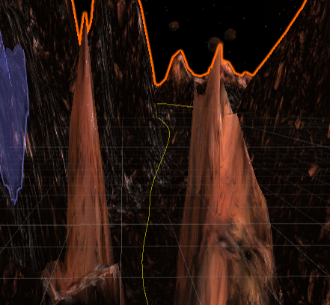Lets choose somewhere in the path to create an overpass. I’m going to raise two columns wide enough for my ship to pass through.
3. Create an **Empty GameObject** and name it **Environment Obstacles**. Reset its transform position.
4. Create a **Cube** GameObject, rename it **Obstacle** and place it inside the Environment Obstacles.
5. Increase it to 50 long and 10x10 for the length and width. 
6. Place it horizontally on top of the two columns and play test it. The goal is to have something to fly underneath.

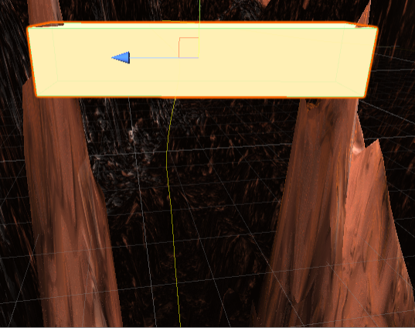

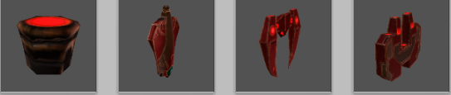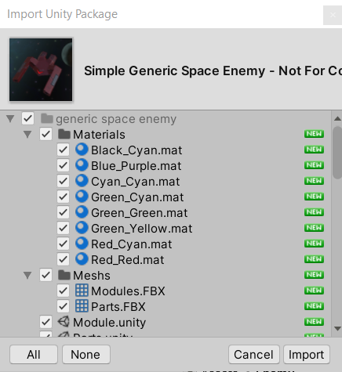I've created two pretty quick obstacles that's going to allow us to test collision. Now we’re going to add enemies for us to shoot at. Now I provided a zip called **Space Enemies** (it cost $5 if youre going to publish your game you can’t use this lol)or quickly look for spaceships you want to use as enemy. Go ahead and download it, unzip, and place in your assets folder. Double click it to **import**. There’s parts for you to build your own ships too.

1. Inside of the **Prefab>Module** folder there’s the premade spaceships.
2. Rename Landing pad to **Staging Area**
3. Place a ship on top of your staging area. WOW its small. Lets **scale** it up. 10x10x10 should make it a good size since we need to see it from a distance. Make sure to **rotate** it too.
4. Inside the Materials folder you can change the color of the ship too.
5. Make sure to apply these changes to the prefab so you don’t have to keep doing them.

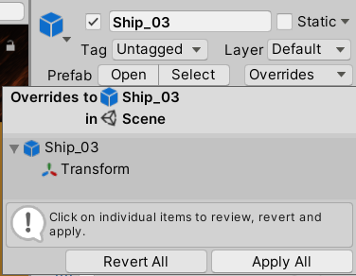

1. Go ahead and drag another enemy out and resize it.
2. Lets find some spots in our map to place enemies. I’m going to stick some above the overhang obstacle we created earlier.
3. Lets play through it and see if we can hit them.
4. They are too small! Lets change the scales to 20x20x20 and lets rotate them down towards the player and play through again.

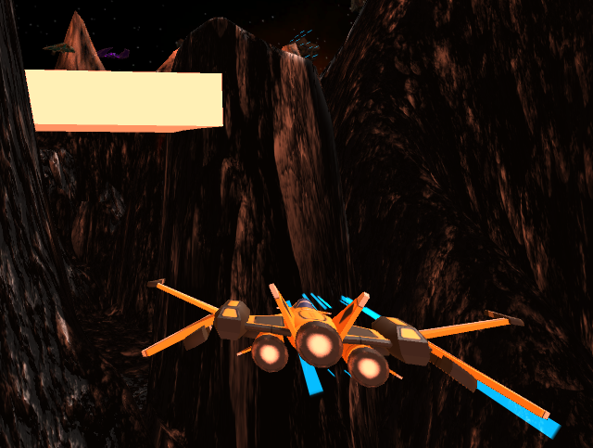

**Challenge time:**

* Create 2 or three obstacles to avoid
* texture the cube you placed (remember not to use your terrain texture but the material you used to create that texture.
* Add 2 or 3 enemies to shoot.
* Share a screenshot of your work!

Create an empty game object called **Enemies** and make sure all of your enemies are saved inside of this GameObject.

